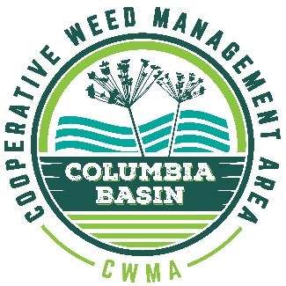
Columbia Basin CWMA December Webinar
December 15, 2021
12 noon Pacific Time – 3 pm Pacific Time
Agenda
12:00 pm | Welcome from Columbia Basin CWMA Co-Chairs | Jenn Andreas, Washington State University, Extension  Craig McLane, MT Fish, Wildlife & Parks
12:10 am | Updates from the Columbia Basin states and provinces, including management plan progress since completion. | - Jeremey Varley, Idaho Dept. of Agriculture  - Craig McLane, Montana Fish, Wildlife & Parks  - TBD, Washington Dept. Of Agriculture  - Tim Butler, Oregon Dept. of Agriculture  - Becky Brown, BC Ministry of Forests, Lands and Natural Resources
1:10 pm | Flathead Lake Control Project | Virgil Dupuis, Salish Kootenai College
1:20 pm | BREAK
1:30 pm | Water Resource Development Act legislation and flowering rush project implementation update | Stephen Phillips, Pacific States Marine Fisheries Commission  Damian Walters, US Army Corps of Engineers
1:45 pm | CABI Biocontrol development for flowering rush: progress and next steps | Jenn Andreas, Washington State University Extension
2:10 pm | Current Control Options / Methods for Established Flowering Rush in Idaho | Jeremey Varley, Idaho Dept. Of Agriculture
2:30 pm | TBD
2:50 pm | Submission of monitoring data call | Greg Haubrich and Brant Carman, WA Dept of Agriculture
3:00 pm | Adjourn

